Green Society Public School
D-15
Ratnanagar-7, Sauraha, Chitwan
Annual Examination-2082
Class: UKG Time: - 2 hrs. F.M.: 50
Sub: Social Science
Name: Roll No.: Sec.:
________________ ______________ OBT.MARKS:
INVIGILATOR EXAMINER
Q.1. Write the name of the community helpers. [3]

Q.2. Name of insects. [3]

Q.3. Name of air transports. [3]

Q.4.Name of sources of water. [4]

Q.5.Write any five polite word. [5]

Q.6. Write down the name of nonliving things. [5]

Q.7. Write down the name of colours. [5]

Q.8. Write down the name of fruits. [5]
Q.9.Answers the following questions in one word. [5]
a. Which is our national animal?

b. Which is our national color?

c. Which is our national bird?

d. Which is our national flower?

e. Which is our national weapon?

Q.10. Write the name of parts of house. [5]
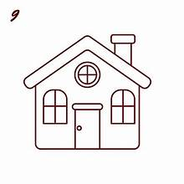

Q.11.Match the followings animal with their home. [6]
Dog Den
Lion kennel
Cow Nest
Bird Shed
Snake Tree
Monkey Hole

Q.12. Tick the good habbit and cross the bad habbit. [6]
a. helping friends. [ ]
b. walk in line. [ ]
c. eating junk food. [ ]
d. fighting with friends. [ ]
e. cutting nail. [ ]
f. watching mobile. [ ]

The End

